Costa Rican Bulk Rock Compositions

Julie M. Coulombe

4/1/2020

Switching gears and taking a look at the bulk composition of the rocks themselves.

Create plot for SiO2 vs Na2O + K2O by each bulk rock 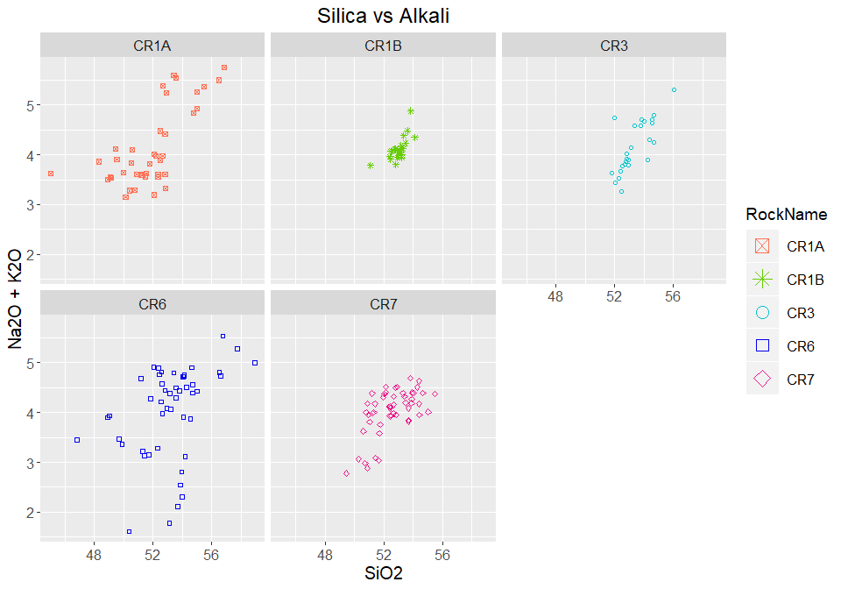

Create plot for SiO2 vs Mg# by each bulk rock 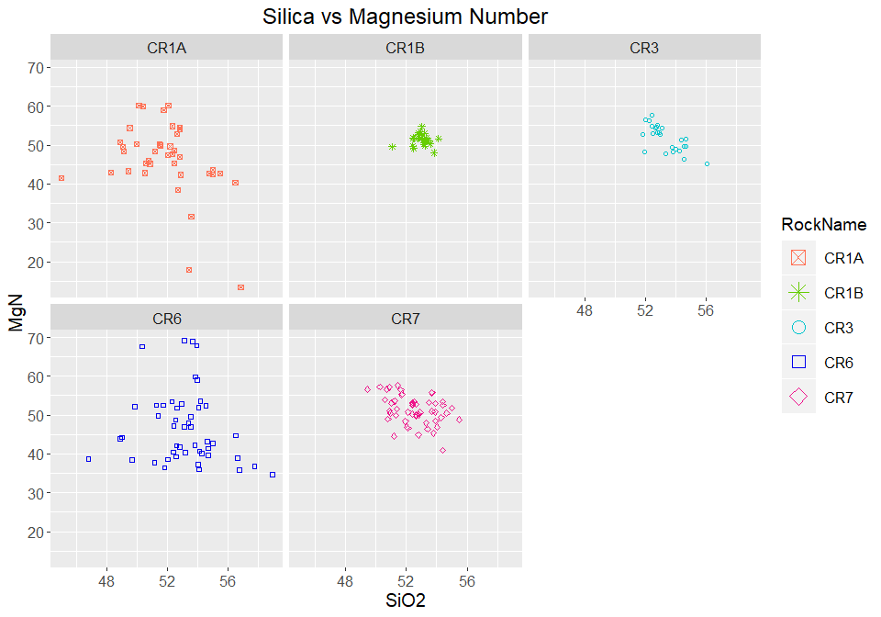

Create plot for SiO2 vs FeO by each bulk rock 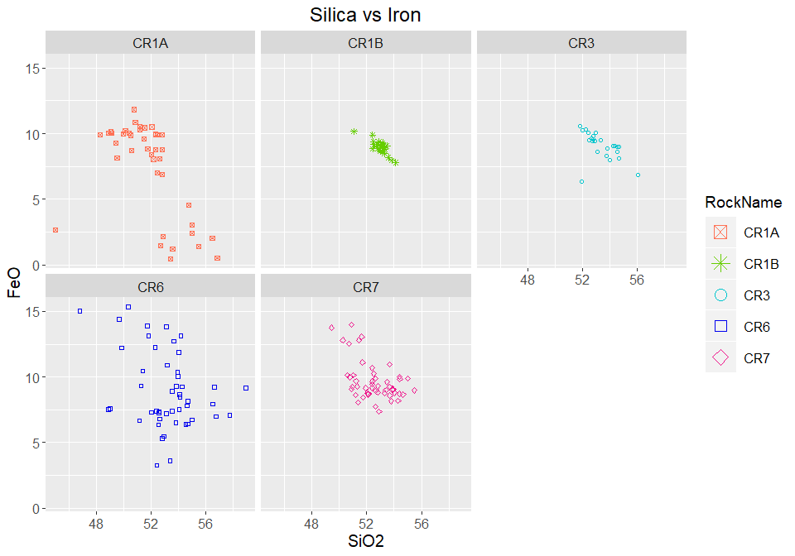

Create plot for Al2O3 vs TiO by each bulk rock 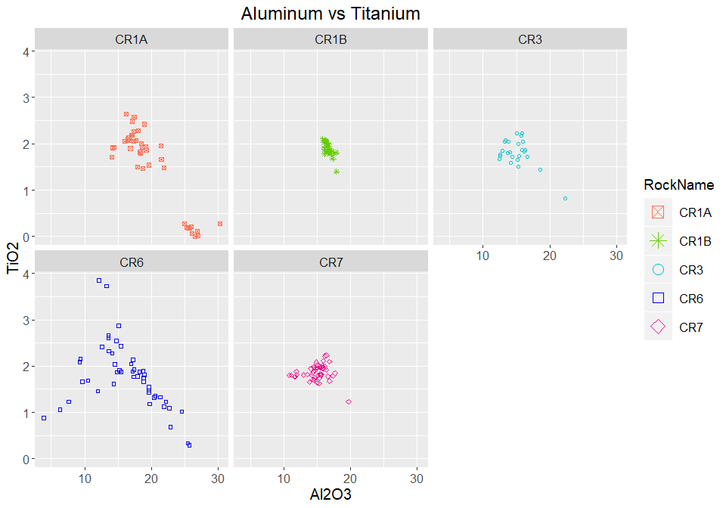

Plot Alkali by Rock Name - Bulk Composition 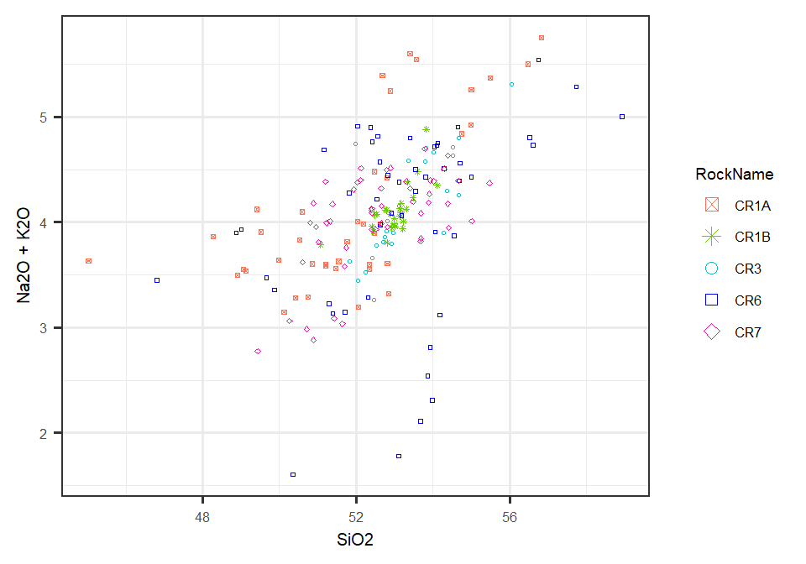

Overlay Alkali Plot on TAS Diagram 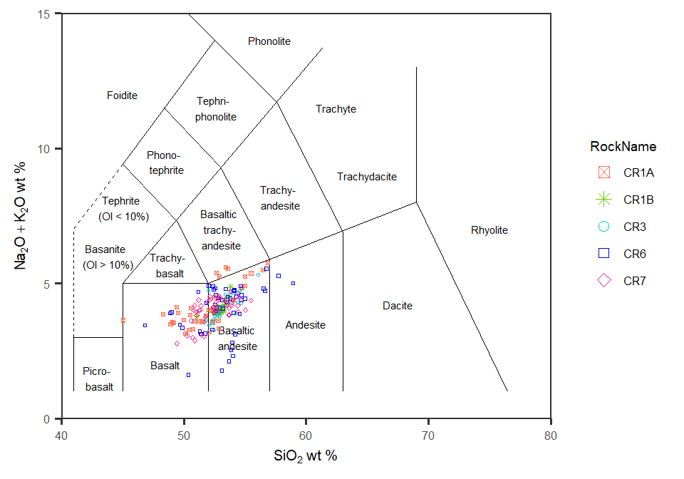

Now to look at plots of all rocks together

Plot Silica vs Mg# by rock 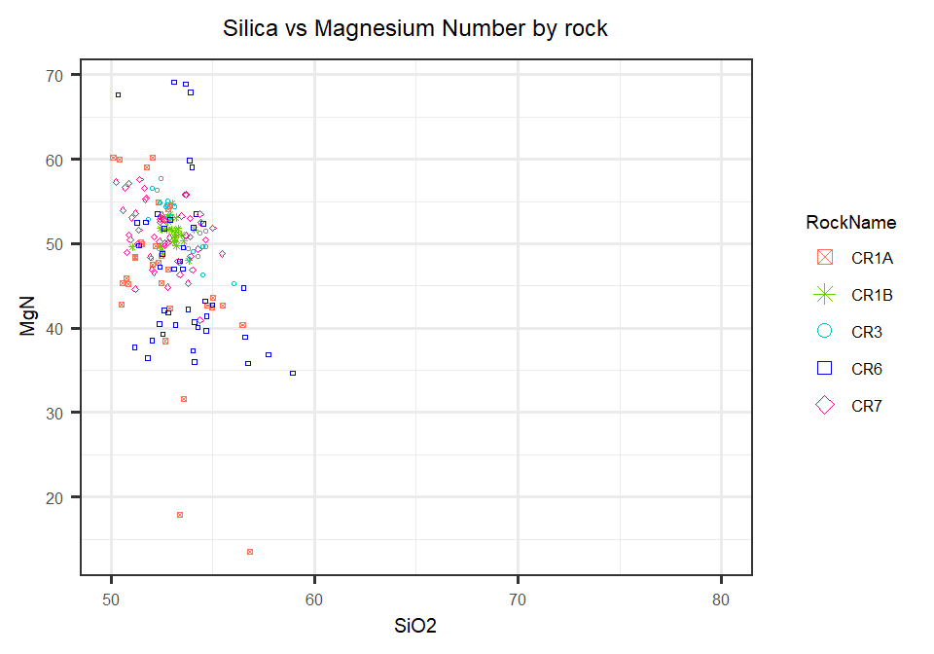

Plot Silica vs Iron by rock 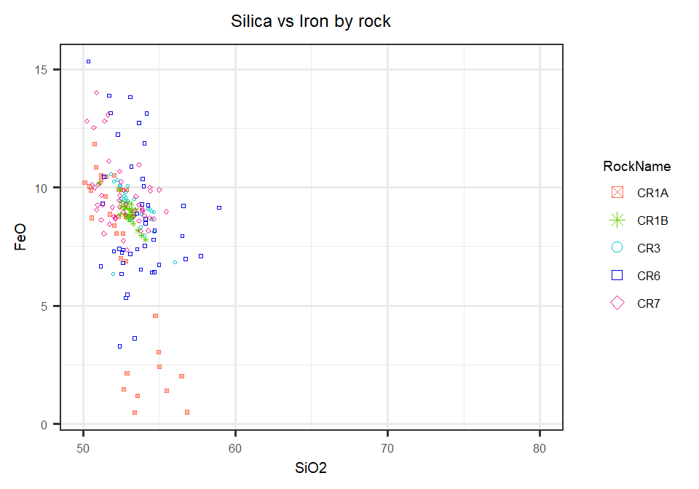

Plot Aluminum vs Titanium by rock

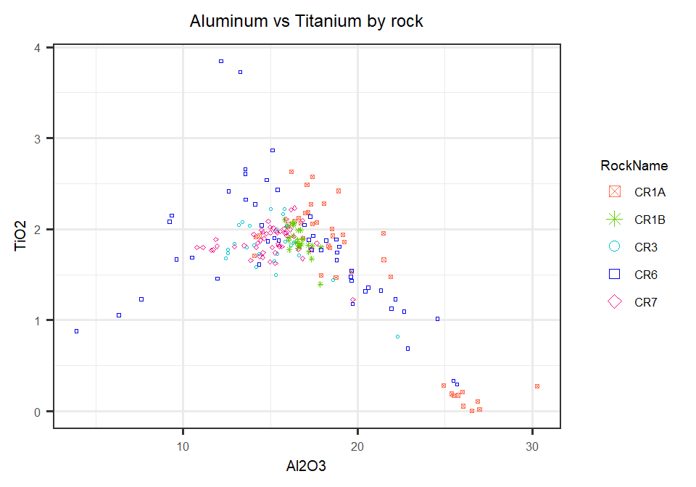

Create plot for looking at CR1A to CR1B Si to Alkali in bulk rock composition

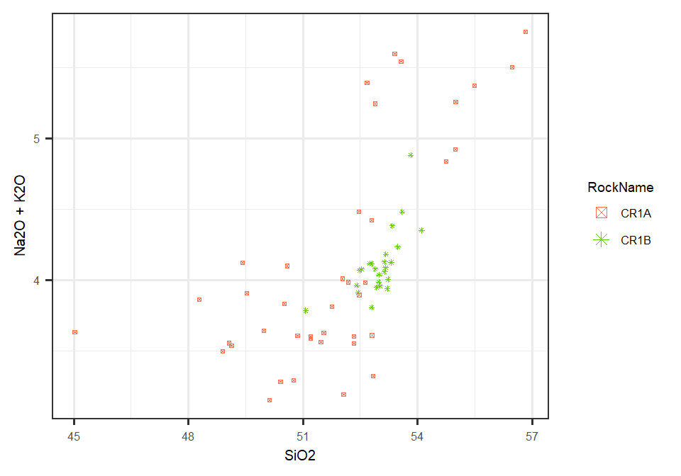

Create plot for looking at CR1A to CR1B Si to Mg# in bulk rock composition 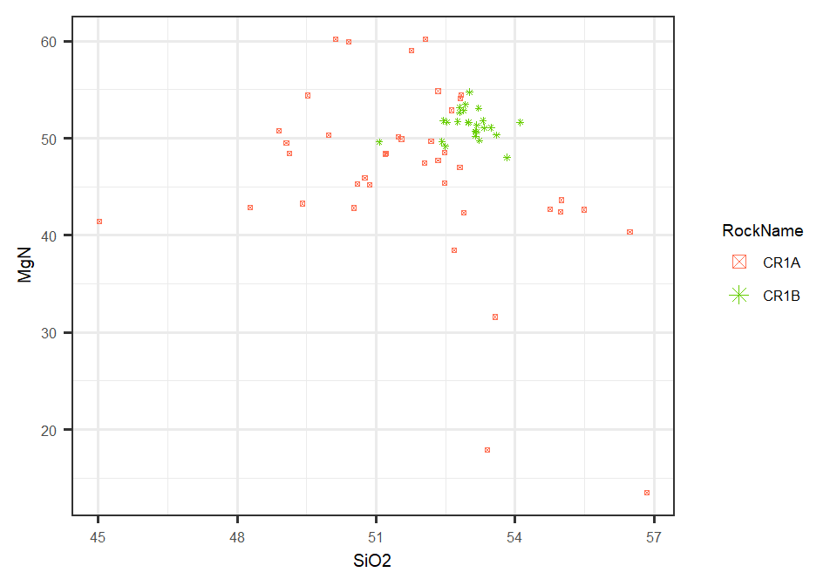

Create plot for looking at CR1A to CR1B Si to Fe in bulk rock composition 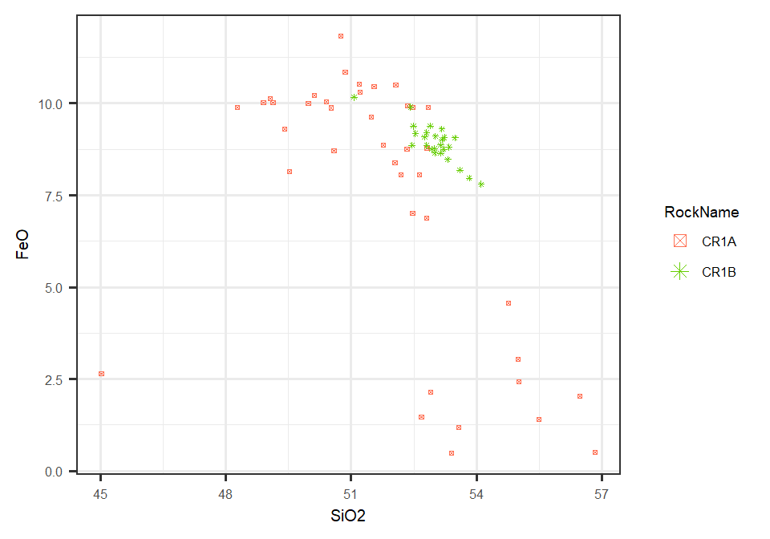

Create plot for looking at CR1A to CR1B Al to Ti in bulk rock composition 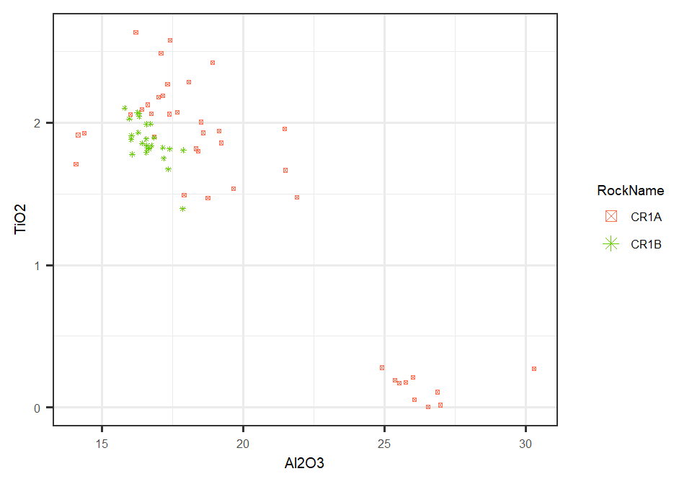

Taking a look at comparing CR2A to CR2B in Bulk Composition (bulk data for CR2 not yet available)